PROJECT DOCUMENTATION

**PROJECT BRIEF**

**Project: ONLINE EVENT MANAGEMENT SYSTEM**

**Date: 03/29/2022**

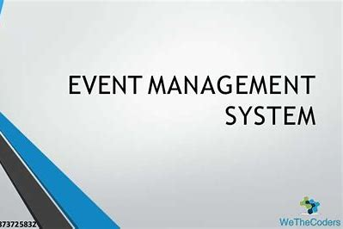

**Owner: GROUP6**

**ONLINE EVENT MANAGEMENT SYSTEM.**

# 1. Project Brief History

## 1.1 Revision History

**Date of this revision:**

## 1.2 Approvals

This document requires the following approvals.

Signed approval forms are filed in the Management section of the project files.

|  |  |  |  |  |  |
| --- | --- | --- | --- | --- | --- |
| **Name** | **Signature** | **Title** | **Date of Issue** |  | **Version** |
| Mr. Nakul |  | Trainer | 02/17/2022 |  | 1 |
| Mr. Appala Koushik | Koushik | Project Manager | 03/29/2022 |  | 1 |

**1.3 Distribution**

This document has been distributed to:

|  |  |  |  |  |  |
| --- | --- | --- | --- | --- | --- |
| **Name** | **Title** | **Sap ID** | **Date Issue** |  | **Version** |
| Mr. Nakul | Trainer |  | 03/29/2022 |  | 1 |
| Mr. Appala Koushik | Project Manager | 51976454 | 03/29/2022 |  | 1 |
| Mr. Cheepurla Raghavender | Team Member | 51977559 | 03/29/2022 |  | 1 |
| Ms. Gandhi Prathyusha | Team Member | 51971254 | 03/29/2022 |  | 1 |
| Ms. Nalla Nikhitha | Team Member | 51978259 | 03/29/2022 |  | 1 |
| Ms. Hasvika M | Team Member | 51971277 | 03/29/2022 |  | 1 |

**2.Table of Contents**

1. Project Brief History……………………………………………………………1

1.1 Revision History……………………………………………………………..1

1.2 Approvals…………………………………………………………………….1

1.3 Distribution…………………………………………………………………...2

2. Table of Contents…………………………………………………………...…2,3

3.Project Brief………………………………………………………………………4

3.1 Purpose………………………………………………………………………. 4

3.2 Introduction…………………………………………………………………...4

3.3 Project definitions………………………………………………………..…..4

3.1 Project objectives……………………………………………………......4

3.2 Project scope…………………………………………………………….4

4. Requirements…………………………………………………………………….5

Software Requirements………………………………………….……………5

5. Use Tools and Technologies…………………………………………………...5

HTML & CSS, Angular……………………………………………………..…5

Spring Boot, Spring JDBC……………….……….…………………………..6

MY SQL, Java Spring Framework……………..…….………………………6

6. Design and Detailed technical updates ………………………………………7

6.1 Sequence Diagram…………………………………………………………..7

6.2 Entity RelationShip Diagram………………………………………….…….8

6.3 Activity Diagram………………………………………………………………9

7. Admin Case Diagram………….………………………………………………10

# 8. Other Technical Implementations…………………………………......11

9. Snapshots………………………………………………………………12

Home page…………………………………………………………...12

Login page…………………………………………………………...12

Register page………………………………………………………...13

Admin Login page…………………………………………………...13

**3. Project Brief**

## 3.1. Purpose

The documents provide information of the project. The project Initiation Document (PID), contains further explanation regarding the ongoing project.

**3.2 Introduction**

* Online Event management system is the applications of project management to the creation and development of events and parties. The project provides most of the basic functionality required for an event. This project to manage different events for different occasions. The system helps the firm to receive the orders from different clients.

**3.3 Project definitions**

**3.1 Project objectives**

* Our aim is to make a user friendly application for users to fix the event
* User can select the event and according to the event the appropriate decoration can be made.
* The project will help clients to decorate for an event and cost required for particular decoration. No need to visit decorators.
* Client will also find out the cost for particular decoration and virtual representation of that particular event.

### 3.2 Project scope

**.** They includes administrative functions, organizer and user function.

**.** Secure Administrative panel.

* Normal users are the participants.
* They have to register for the events.

**4. Requirements**

**Software Requirements**

* Windows Version 7+
* A Browser Which supports HTML & JavaScript.
* Front- end software: HTML&CSS, Angular.
* Back-end software: Spring Boot, JDBC

**5. Used tools and Technologies**

* **Front end:** HTML&CSS, Angular.
* **Back end:** Spring Boot, JDBC
* My SQLDatabase.

**Online Tools**

* Word
* PowerPoint

**HTML & CSS**

HTML (The Hypertext Markup Language) and CSS

(Cascading Style Sheets) are two of the core technologies for building Web pages.HTML provides the structure of the page, CSS the (visual and aural) layout, for a variety of devices. Along with graphics and scripting, HTML and CSS are the basis of building Web pages and Web Applications.

**Angular**

Angular is a platform and framework for building single-page client applications using HTML and Typescript. Angular is written in Typescript. It implements core and optional functionally as a set of typescript libraries that you import into your applications.

**Spring Boot**

Spring Boot is an open source Java-based framework used to create a micro Service. It is developed by Pivotal Team and is used to build stand-alone and production ready spring applications. Spring Boot is a module of spring for packing the Spring-based application with sensible defaults. Spring MVC is a model view controller- based web framework under the spring framework. It provides default configurations to build spring-powered framework.

**Spring JDBC**

Spring allows handling database access with the help of the spring JDBC Template. Spring JDBC allows cleaning up the resources automatically. Also, it converts the JDBC SQL Exceptions into Run-time Exceptions. It provides flexibility to the programmers to react to the errors. It also converts the vendor-specific error messages into an easy and understandable message.

**My SQL**

MySQL is an Oracle-backed open source relational database management system (RDBMS) based on Structured Query Language (SQL).

MySQL runs on virtually all platforms, including Linux, UNIX and Windows. Although it can be used in a wide range of applications and online publishing.

MySQL is an important component of an open source enter price stack called LAMP. LAMP is a web development platform that uses Linux as the operating system, Apache as the web server, MySQL as the relational database management system and PHP as the object-oriented scripting language. (Sometimes Perl or Python is used instead of PHP).

**Java**

Java is an object-oriented programming language that produces software for multiple platforms. When a programmer writes a Java application, the compiled code (Known as bytecode) runs on most operating systems (OS), including Windows, Linux and Mac OS.

**6. Design and Detailed technical updates**

**<Provide details of the Design/approach for developing/implements the requirements>**

**6.1 Sequence diagram**

|  |  |
| --- | --- |
| **Brief Description** | **Admin Registration** |
| **Basic Flow** | This use case describes how a client register into the system.  1.The client has to register himself into the system.  2. After the successful registration, client will get a success  Message.  3. The following information is required during registration.  * Name  **\*** Email  * Mobile Number  * Password. |
| **Alternate Flow** | The system will validate the information provided. If any invalid  Data is found, the input form will be redirected with error Message. |
| **Validation** | 1.Name is required and can’t be empty.  2.Address can’t be empty.  3.The Email should be valid.  4. Account details should be valid. |
| **Pre-Conditions** | Admin and organizer should have network access and Browser with latest Updates. |
| **Post-Conditions** | Success Message should be shown. |

**6.2 Entity-Relationship Diagram**

Admin

Organizer

User

**6.3 Activity Diagram**

ORGANIZER

Login

Register

Manage venues

View bookings

Booking history

ADMIN

**Design Approach**

Login

View booking

View venues

View organizers

View users

USER

Login

Register

View venues

Book event

Booking history

Payment

**7. ADMIN CASE DIAGRAM**

Database Queries

A

D

M

I

N

Login

View booking

Stop

Logout

View venues

View organizers

View users

**8. Other Technical Implementations**

**Layer Logical view Technology /**

**Framework**

Delete

**Presentation layer**

Delete

**Angular,**

**HTML&CSS**

Update

Add

Controllers

Configuration

**Application/**

**Business layer**

**Spring Boot**

REST Controllers

Service

**Spring JDBC**

Entity/ Model Classes

Data Access Layer Spring JPA

Repository classes

MYSQL

**9. Snapshots**

**HOME PAGE**

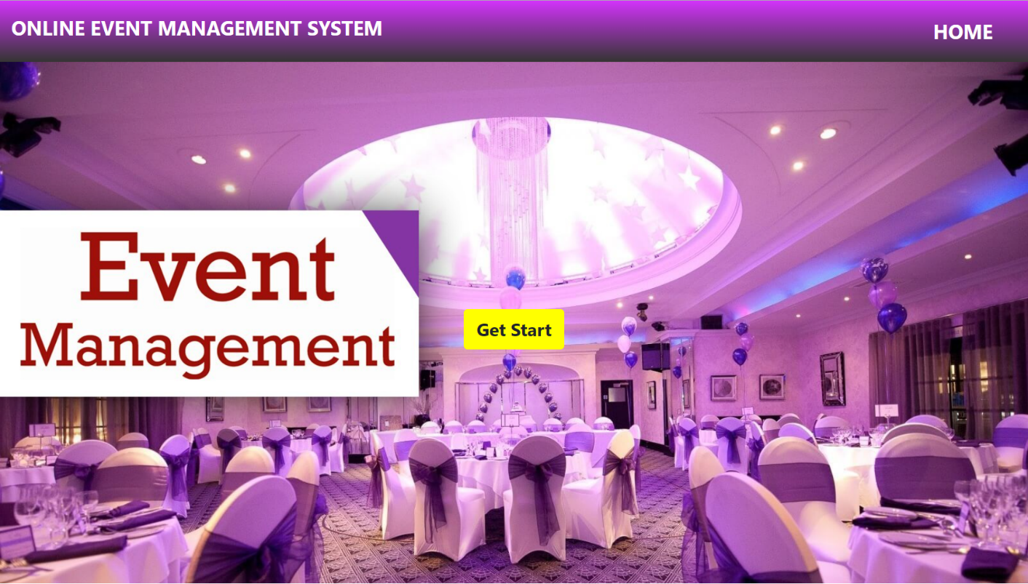

**LOGIN PAGE**

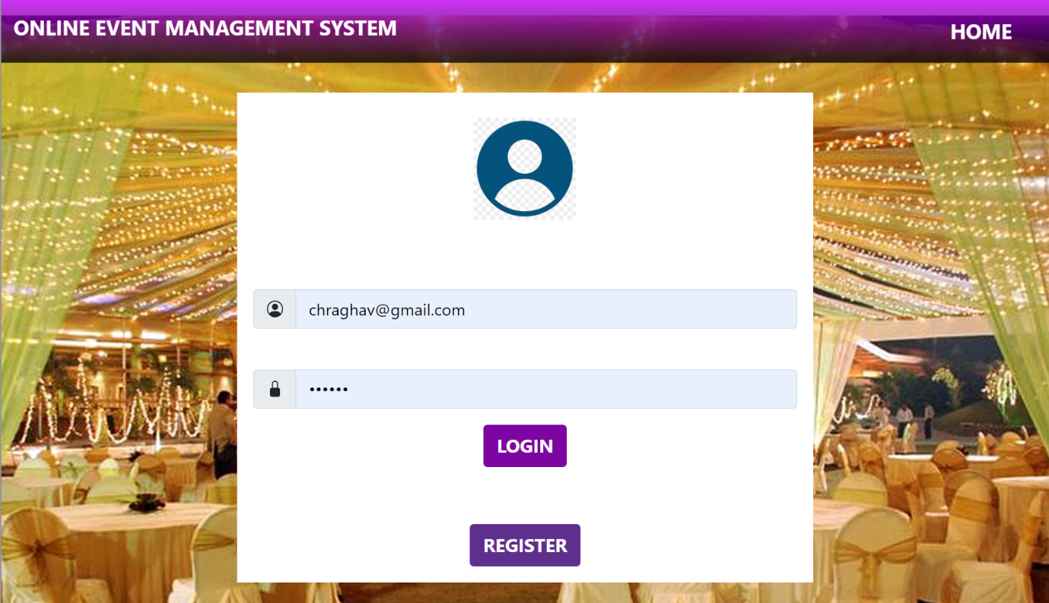

**REGISTER PAGE**

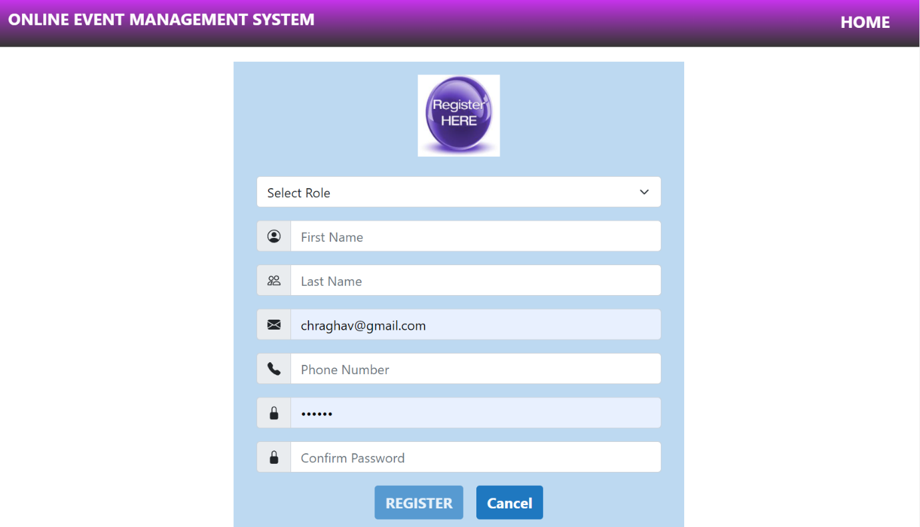

**ADMIN LOGIN PAGE**

